

**FINANCIAL MANAGEMENT – MBA 440**

**VALUATION PROJECT: COSTCO WHOLESALE CORPORATION**

**BY**

**CELDRICK NDZE KUTA, CHIAMAKA EREGHAN, ERIC AGYEMANG, KELVIN NII LARTEY-ABRAHAMS**

**APRIL 17, 2020**

**SUMMARY**

Costco Wholesale Corporation is members-only warehouse store, selling a variety of merchandise. In this report, we conducted a valuation of Costco stock and assessed whether to sell, hold or buy their stock. Using the discounted cash flow estimation method, our valuation resulted in a share price of $193.532. This estimated share price is significantly lower than Costco’s share price of $301.33. (Retrieved April 22, 2020 from [*https://www.msn.com/en-us/money/stockdetails/fi-a1q6k2*](https://www.msn.com/en-us/money/stockdetails/fi-a1q6k2)).The initial decision was to sell but using the 40% discrepancy, a percentage change of 35.7740654% was obtained. This value is less than 40%, indicating that instead of selling, we must ‘hold’ the stock and speculate that the market price of Costco could go higher to possibly make more gains. We then run a sensitivity analysis of two key factors (terminal growth rate and expected return) that drove the valuation to assess effects on the estimated share price. Based on our valuation and the results of our sensitivity analysis, majority confirmed holding Costco stock.

**1.0 DESCRIPTION OF BUSINESS**

**1.1 Sales Model**

Typical Costco Warehouses carry only 3700 distinct products, compared to Walmart, who carry approximately 140,000 products. Costco does not stock products whose wholesale price they feel is too high. (“Costco,” n.d., para. 12). Such an incidence occurred in 2009, when Costco refused to sell Coca Cola products mainly because of the need to give consumers lowest prices possible in order to compete with other companies like Walmart.

**1.2 Products**

Costco has an inventory that changes often. The company is renowned for carrying products temporarily and then later converting them into seasonal products. Initially selling only boxed items, it has gradually expanded its range of products and services; it now sells many more difficult-to-handle products such as caskets, clothing, computer software, home appliances and perishable food such as dairy, meat and sea food. Many Warehouses have gas stations and pharmacies. (“Costco,” n.d., para 16).

**1.3 Services**

Costco offers a wide variety of services, apart from mainly food services. It offers Concierge Services to members who purchase electronic gadgets to help them understand how to use products to avoid the potential situation of returning something they have bought. (“Costco,” n.d., para 21) Costco has an auto program, where it teams up with various auto manufacturers to offer special deals to customers. As of September 2015, Costco was the second largest auto seller in the US after AutoNation. (“Costco,” n.d., para 24). Costco has an optical company, Costco Optical, which was the 5th largest optical company in the US as of 2015. (“Costco,” n.d., para 26).

**2.0 BRIEF HISTORY OF COSTCO**

Costco Wholesale Corporation is an American Corporation which operates a chain of membership-only Warehouse Clubs. As of 2016, it was the world’s largest retailer of choice and prime beef, organic food, Rotisserie chicken and wine. (“Costco,” n.d., para 1).

The beginnings of Costco could be traced to as far back as 1976, when Sol Price, together with his son, nephew and others found the Price Club. It’s first location was in a converted airplane hangar on Moreno Boulevard in San Diego. Price Club was originally limited to serving only small businesses; members who could purchase a wide range of supplies and wholesale items. James Sinegal, a protégé of Sol Price transformed the Price Club by introducing strategies for expansion to a select audience of non-business members. In 1983, James Sinegal along with Seattle retailer James Brotman founded Costco Wholesale which run independently of Price Club but for the next 10 years, both companies continued to innovate and grow until 1993, when both companies decided to merge operations due to growing competition from Walmart. The merged company became known as Price Costco.

Price Costco membership became Universal, had 206 locations, and generated $16 billion in sales annually. In 1997, Price Costco was rebranded Costco Wholesale Corporation, 3 years after the Price brothers left the company to form Price Enterprises, a warehouse club chain in Central America and the Caribbean. In 2019, Costco was ranked 14th on the Fortune 500 rankings of the largest United States corporations by total revenue. (“Costco,” n.d., para 5).

**3.0 RECENT DEVELOPMENTS**

In the wake of the global pandemic, coronavirus, Costco's most recent performance in the market has been compared to arguably its biggest competitor, Walmart. The effects of coronavirus have seen consumers stock up essentials from these two big retailers at an alarming rate. This has resulted in the plunge of the Costco stock by 7% (As of April 2, 2020) while Walmart's stock is still almost flat. Nonetheless, both have still outperformed the S&P 500 within this period, as the S&P 500 has declined by more than 20%. Does this necessarily mean Walmart is doing better? Based on the analysis done, Costco has seen an average growth rate of 7% compared to Walmart's 2% between 2014 and 2019 and the average annual adjusted earnings per share growth for Costco was also higher at 12% as compared to -14% for Walmart. This led to a conclusion that on an overall basis, Costco’s stock could outperform Walmart’s stock throughout the current crisis. In other recent developments, Costco’s stock is trading in a neutral price range now. It set its all-time in trading high of $325.25 on February 21, 2020, which rapidly decreased to $271.28 on February 28, 2020, decreasing by 16.5%. Such a [1]trading range is expected to hold for the foreseeable future.

**4.0 PRIMARY COMPETITORS**

Costco’s main competitors are Amazon, Walmart, and Target. Walmart is a retailing Corporation that operates a chain of hypermarkets, department stores and grocery stores. Target is a public retail, clothing and consumer products and services provider. Other less known competitors along Costco’s line of business are Home Depot, Best Buy, Office Depot, Aldi UK, Sam’s Club and Lowe’s. To get some perspective of how Costco compares to its main competitors, Table 1 lists some key information about revenue, expenses, cash dividend per share, operating income and some information about operation on [2]social media for Costco as well as its main competitors.

Table 1. Summary of key factors of comparison.



**5.0 DISCUSSION OF SALES, PROFITABILITY, EARNINGS GROWTH AND DIVIDEND**

5.1 Profitability Measures

Table 2. Profitability ratios.



Table 2 summarizes profitability ratios for Costco for the previous 6 years. The following are some key takeaways from the diagram:

* Costco’s gross profit margin decreased from 2017 to 2018 and from 2018 to 2019.This means that since 2017, there has been a decrease in the percentage of revenue available to cover operating and other expenditures.
* Costco’s operating margin rose steadily from 2014 to 2016 and has so far deteriorated from 2017 to 2019.It has decreased faster than gross profit margin, which may indicate that the company’s proportion of revenue available to cover non-operating expenses has decreased over recent years.
* Costco’s net profit margin decreased from 2014 to 2016 but has been on the rise since, hitting 2.46% in 2019. This is an indication that Costco is in good financial health and as such is generating enough profit from its sales to contain operating and overhead costs.
* Costco’s return on equity increased to 2017 and decreased steadily to 24% in 2019, This may be due to the company in recent years being unable to generate profits from its shareholders’ investments.
* Costco’s return on assets has increased steadily over the past few years. This indicates that the company has been able to utilize its assets efficiently to earn more money on less investment.

**5.2 Historical Performance**

Here, Costco’s historical performance is compared to arguably its biggest competitor, Walmart:

Figure 1. COST. STOCK PRICE WMT STOCK PRICE

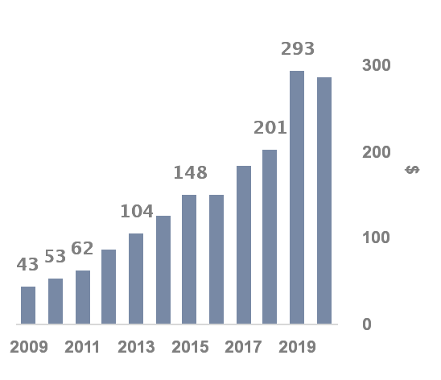 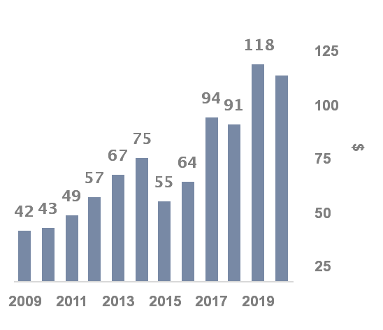

Comparing both stocks, we realised that over the decade, Costco and Walmart stocks have both generally risen. However, Costco stock has increased by approximately [3]581%. During the same period, Walmart has increased by approximately [4]181%. This implies that Costco was growing at a rate of [5]3.2 times Walmart stock.

**5.3 Historical EPS Growth**

The historical EPS growth of both companies are compared to get an idea of which company’s stock is more attractive. Figure 2 compares the annualized EPS growth for both companies. It is realised that Costco’s EPS growth of 12% within this period is way higher than Walmart’s rate of -14.2%.

Figure 2. 2014-2019 Annualized EPS growth comparison

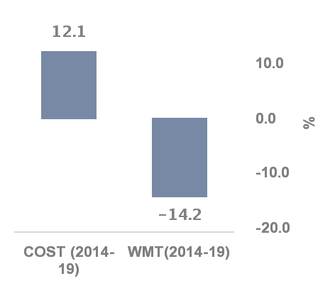

From Figure 3, we realise that Costco’s annual changes in EPS have been fairly stable, compared to Walmart’s annual changes in EPS, which have fluctuated wildly during the period. This implies that Costco’s stock looks much more attractive than Walmart’s stock.

Figure 3 COST ANNUAL CHANGES IN EPS WMT ANNUAL CHANGES IN EPS

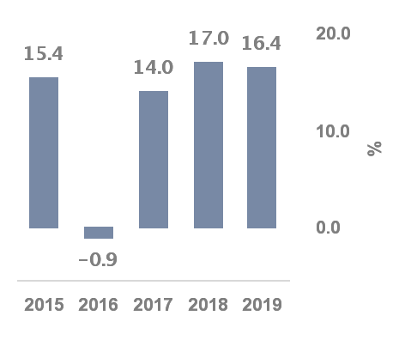 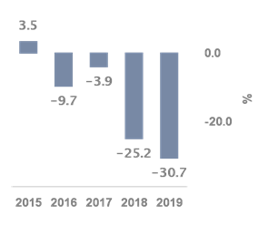

**5.4** **Recent Trends in Dividend**

Figure 4 trends in dvidend cost vs wmt

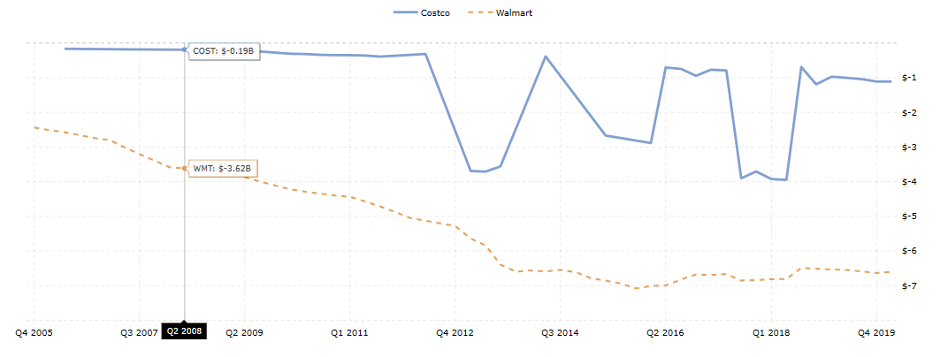

Figure 4 shows the dividend trends for Costo and its competitor, Walmart. Costco dividend payment has been quite unstable over the past decade but have smoothed out since 2018. Walmart however, have endured a steady decline over the years.

**6.0 VALUATION CALCULATIONS**

**6.1 Expected Return on Market In The Long Run**

When calculating the Expected Return on Market (I/Y) in the long run, the S&P 500 Market Index, which measures the performance of the largest 500 companies listed on stock exchanges in the United States, was used. On December 31, 1965, the Present Value (PV) of the S&P 500 was $92.43 while the Future Value (FV) was $3230.75 (Retrieved on April 20, 2020 from [***https://finance.yahoo.com/quote/%5EGSPC/history?period1=1574899200&period2=1580515200&interval=1d&filter=history&frequency=1d***](https://finance.yahoo.com/quote/%5EGSPC/history?period1=1574899200&period2=1580515200&interval=1d&filter=history&frequency=1d)***, n.d.***). Using the concept of Present Value (PV), the I/Y in the long run, choosing our starting point to be [6]1965, is calculated below:

2ND CLR TVM

92.43 +/- PV

2019-1965 = 54 [7]N

3230.75 FV

CPT I/Y; I/Y = 6.8029455%

**6.2 Cost of Equity**

To calculate the cost of equity (ke), the Capital Asset Pricing Model is used. Mathematically this is given as ke = rf +*β*(E(Rmkt)- rf ) where rf is the risk free rate for treasury bonds, E(Rmkt) represents the expected return on the market in the long run and *β* is the beta for Costco. The rf was 1.638% on March 20, 2020. (Retrieved from [***https://www.wsj.com/market-data/quotes/bond/BX/TMUBMUSD30Y***](https://www.wsj.com/market-data/quotes/bond/BX/TMUBMUSD30Y)***, n.d.***). Also, *β* was 0.9 on January 31,2020. (Retrieved from ***https://finance.yahoo.com/quote/COST/key-statistics***). Hence, the cost of equity is calculated as follows:

$K_{e}$ =1.638%+0.9(6.8029455%−1.638%) **=** 6.286451%

**6.3 Weighted Average Cost of Capital (WACC)**

To evaluate WACC, a few parameters were needed: The Corporate Tax Rate (tc), the Cost of Debt (kd) and Cost of Equity (ke). To obtain tc, the Provision for Income Taxes and Income before Income Taxes are needed. From the Consolidated Income Statement, the Provision for Income Taxes is given as 1061 and Income before Income Taxes is given by 4765. tc therefore is calculated as:

Tax rate (tc) = = = 22.2665268%.

kd was given as 2.30% (Retrieved on March 20, 2020 from [***https://www.stock-analysis-on.net/NASDAQ/Company/Costco-Wholesale-Corp/Analysis/Deb***](https://www.stock-analysis-on.net/NASDAQ/Company/Costco-Wholesale-Corp/Analysis/Deb)***t, n.d.***)

So, the yield on debt after taxes is given as: kd (1- tc). Then,

Yield on debt after taxes **=** 0.023(1-0.22266528) = 1.7878699%

From the Consolidated Balance Sheet for Costco, the Market Value of Debt (MVD) consists of the “Current portion of long term-debt” and “long term debt, excluding current portion”. This sums up debt to:

MVD = $5124M + $1699 M= $6823 million

Costco had a total of 441.58 million shares as of March 4, 2020 (Retrieved April 20, 2020 from [*https://ycharts.com/companies/COST/shares_outstanding*](https://ycharts.com/companies/COST/shares_outstanding)*, n.d.*). As of April 22, 2020, Costco had a share price of $301.33 (Retrieved April 22, 2020 from [*https://www.msn.com/en-us/money/stockdetails/fi-a1q6k2*](https://www.msn.com/en-us/money/stockdetails/fi-a1q6k2)*, n.d.*). The Market Value of Equity (MVE) is given as

MVE = Price of 1 share of Costco Stock* Total Number of shares outstanding. Therefore,

MVE = $301.33×441.58 million = $133061.3014 million.

With the given data, WACC is given as

WACC = $\frac{MVD*kd\left(1-tc\right)+MVE(ke)}{MVE+MVD}$ which can be calculated as follows:

WACC $=\frac{6823\left(1.7878699\%\right)+133061.3014(6.286451\% )}{6823+133061.3014}=6.0670281\%$

**7.0 CASH FLOW ESTIMATION**

The cash flow for year end 2019 (most recent year) consists of the sum of all business-related cash flows, which in this case are the positions in the Cash Flow Statement “Cash provided by operations” and “Capital Expenditure”. “Other investing activities” was included in the cashflow valuation because on the part of Costco, it is a business-related activity and therefore potentially affects the cashflow valuation. The free cashflow for 2019 is calculated in the table below:

Table 3: free cashflow for 2019

On March 3, 2020, the estimated annual growth for the next five years for Costco was 5.88% (Retrieved from [*https://finance.yahoo.com/quote/COST/analysis?p=COST*](https://finance.yahoo.com/quote/COST/analysis?p=COST)*, n.d.*) .

The cash flows for the next five years can be calculated as follows:

*CF20*=$3354𝑀×1.0588=$3351.2152𝑀

*CF21*= $3351.2152𝑀×1.0588=$3760.026654𝑀

*CF22*= $3760.026654𝑀×1.0588=$3981.116221𝑀

*CF23* = $3981.116221𝑀×1.0588=$4215.205855𝑀

*CF24* = $4215.205855𝑀×1.0588=$4463.059959𝑀

Next, the Constant Growth Perpetuity (CGP) was computed. A reasonable growth rate of [8]1.6% is assumed after 5 years:

𝐶𝐺𝑃 = $\frac{\$4463.059959M}{0.060670281\%-1.6\%}$ = $99911.16821𝑀

The adjusted cash flow for the year 2023 therefore sums up to CF23=$99911.16821𝑀+$4215.205855M=$104126.3741𝑀.

**7.1 Present Value**

To calculate the present value of the firm, the cashflows listed above are discounted using the WACC as the appropriate discount rate:

𝑃𝑉(Firm)= $\frac{\$3351.2152M}{1.060670281}$ + $\frac{\$3760.026654M}{{1.060670281}^{2}}$ + $\frac{\$3981.116221M}{{1.060670281}^{3}}$ + + $\frac{\$104126.3741M}{{1.060670281}^{4}}$ = $92296.11116𝑀

**7.2 Estimated Share Price**

The estimated share price is calculated by dividing the difference in the Present Value of the Firm and the Market Value of Debt by the Total Number of Shares Outstanding:

Estimated Share Price = $\frac{(\$92296.11116M-\$6823M)}{441.58M}$ = $193.5620072M

**8.0** **SENSITIVITY ANALYSIS**

We would now like to test what happens to the estimated share price when the market return and the assumed growth rate are varied by running a sensitivity analysis. This helps to give another perspective to the share price when the assumptions of the model are changed. Since Costco is a mature firm with a relatively steady market share and revenue, relatively low growth rates are assumed. Since terminal growth rates usually range between historical inflation rates of 2% and 3%, (Retrieved from [***https://www.divestopedia.com/definition/6598/terminal-growth-rate on April 23***](https://www.divestopedia.com/definition/6598/terminal-growth-rate%20on%20April%2023), 2020) we assumed terminal growth rates of 2.5% and a much lower 1.25%. We arrived at expected market returns of 5.5% and 7.5%, either side of the one calculated, 6.8029455%. This is to account for the possibility of a [9]bear or [10]bull economy in the future. The results of the sensitivity analysis run are shown below:

Table 4. Sensitivity analysis by varying expected return and terminal growth rate



There are a range of possible prices per share in the table based on different combinations of the two drivers. We consider the two most extreme cases; firstly, when expected return is lowest (5.5%) and terminal growth is 2.5%, the share price shoots up to $355.4076160. On the face of it, we would recommend that the stock be bought, since it is under-priced. Using the 40% rule, it is realised that the percent change between the share price of $301.33 (As of April 22, 2020) and $355.4076160 is 17.94631% which is far less than 40%. This means instead of buying, it is better to hold stock and speculate for higher market prices. Moreover, at a growth rate of 1.25% and an expected return of 7.55%, the share price is $158.6062673, the lowest value in the sensitivity analysis. In this case, we would want to sell. Employing the 40% rule again, the percent change between the share price of $301.33 (As of April 22) and $158.6062673 is 47.3645945%, which is more than 40%, so the ‘sell’ recommendation still holds. Between these two extremes, most of the share prices will recommend holding Costco stock, with $168.5751964 being the only one that leads us to conclude selling Costco stock.

**References**

Costco. (n.d.). In Wikipedia. Retrieved from *https://en.wikipedia.org/wiki/Costco* on March 20, 2019.

Costco Jobs (n.d.). Retrieved from [*https://www.costco.com/about.html*](https://www.costco.com/about.html%20on%20March%2015)on March 15, 2020.

(n.d.). Retrieved from [*https://finance.yahoo.com/quote/%5EGSPC/history?period1=1574899200&period2=1580515200&interval=1d&filter=history&frequency=1d*](https://finance.yahoo.com/quote/%5EGSPC/history?period1=1574899200&period2=1580515200&interval=1d&filter=history&frequency=1d) on April 20, 2020.

Terminal Growth Rate. (January 24, 2017). Retrieved from [*https://www.divestopedia.com/definition/6598/terminal-growth-rate* on April 23](https://www.divestopedia.com/definition/6598/terminal-growth-rate%20on%20April%2023), 2020.

(n.d.). Retrieved from [*https://finance.yahoo.com/quote/COST/analysis?p=COST*](https://finance.yahoo.com/quote/COST/analysis?p=COST)on April 20, 2020.

(n.d.) Retrieved from [*https://ycharts.com/companies/COST/shares_outstanding*](https://ycharts.com/companies/COST/shares_outstanding)*,* on April 23, 2020.

(n.d.) Retrieved from [*https://www.stock-analysis-on.net/NASDAQ/Company/Costco-Wholesale-Corp/Analysis/Debt* on March 31](https://www.stock-analysis-on.net/NASDAQ/Company/Costco-Wholesale-Corp/Analysis/Debt%20on%20March%2031), 2020.

(n.d.) Retrieved from [*https://www.macrotrends.net/2324/sp-500-historical-chart-data* on April 27](https://www.macrotrends.net/2324/sp-500-historical-chart-data%20on%20April%2027), 2020.

Is Costco Expensive Or Cheap After a -7% Move vs Walmart Corp .? (n.d.). Retrieved from [*https://dashboards.trefis.com/data/companies/COST/no-login-required/v4zMUXQy/Is-Costco-Expensive-Or-Cheap-After-A-6-5-Move-vs-Wal-Mart-Corp-?fromforbesandarticle=trefis200402*](https://dashboards.trefis.com/data/companies/COST/no-login-required/v4zMUXQy/Is-Costco-Expensive-Or-Cheap-After-A-6-5-Move-vs-Wal-Mart-Corp-?fromforbesandarticle=trefis200402) on March 13, 2020.

1. Trading Range: This occurs when a security trades between consistently high and low prices for a long time. Top prices represent a point of price resistance, where it is advisable to sell the security and bottom price represent a position of support for the security, where it is more advisable to buy
2. With social media on the rise, it is essential that businesses capitalize on the opportunity to outshine their competitors on leading platforms so social media is an important factor to consider.
3. (293-43)/43 *100 = 581.3953488%.
4. (118-42)/42*100 = 180.952381%.
5. 5.8813953488/1.80952381 ~ 3.2
6. The year 1965 was chosen to make the estimate for the expected return in the long run as accurate as possible.
7. N represents the difference between the years 1965 and 2020.
8. We assume a constant growth rate according to the Dividend Discount Model
9. A bear economy occurs when the economy is in a recession and unemployment is high, or when inflation is rising quickly.
10. A bull economy occurs when the economy is strengthening or when the economy is already strong.